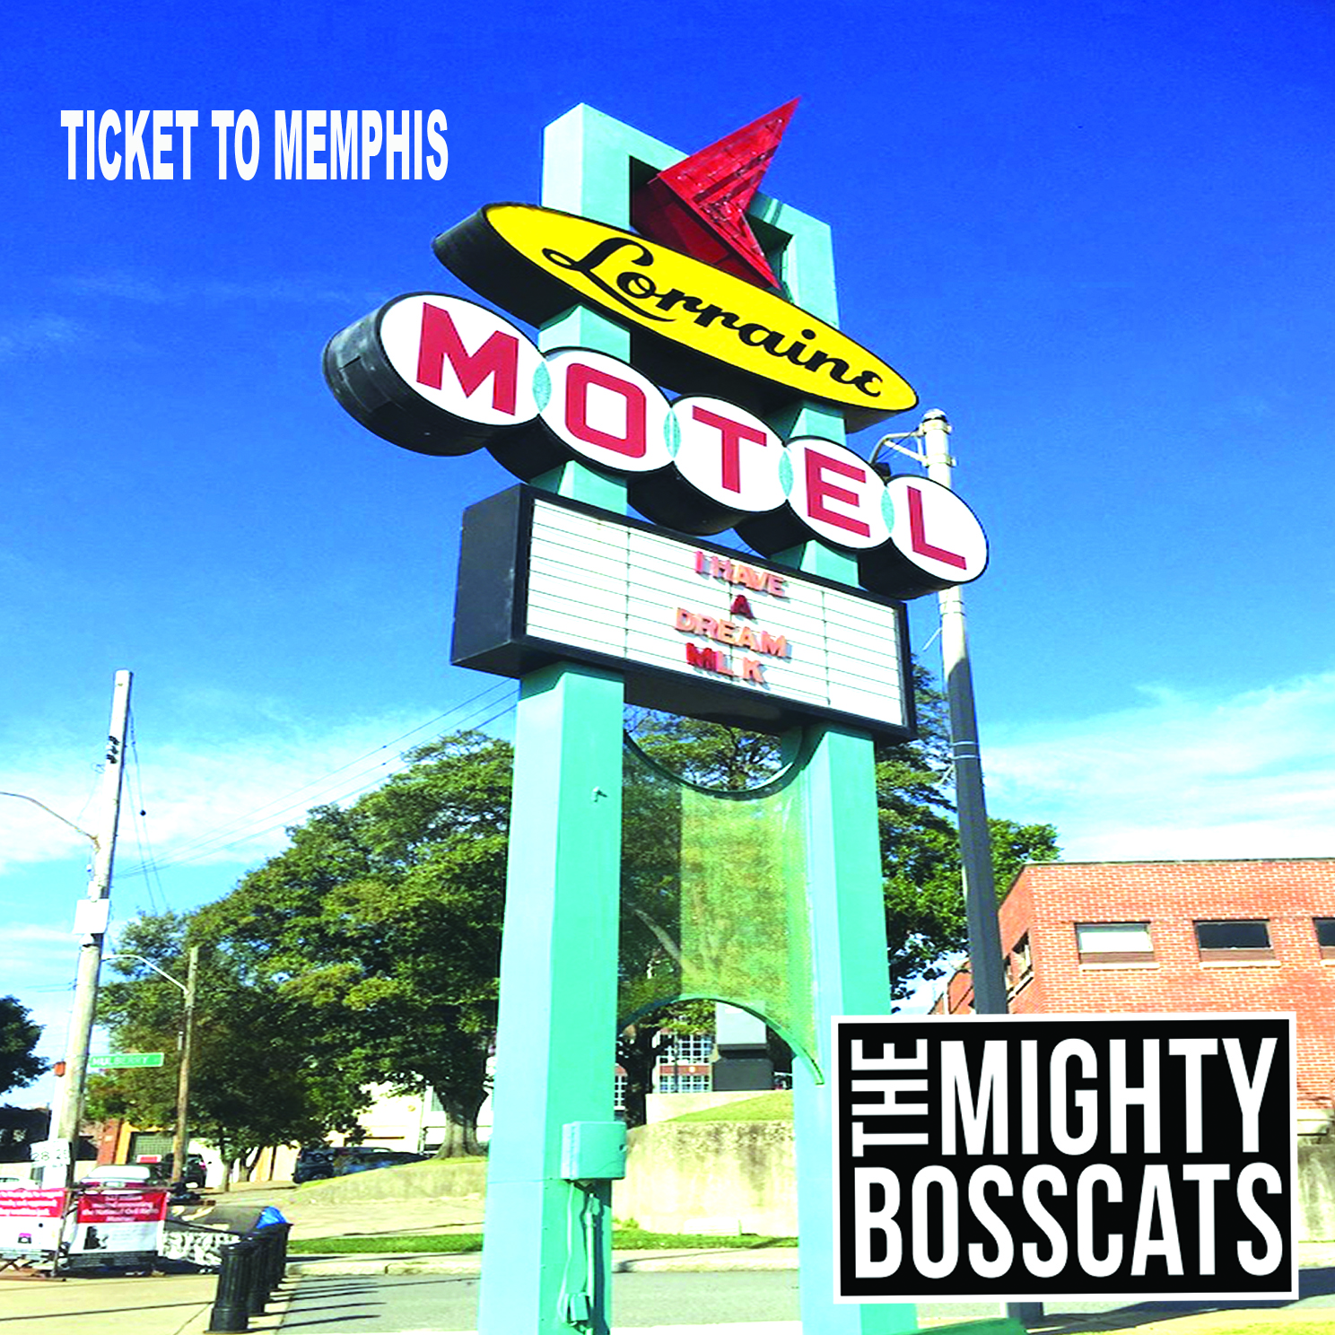

Ticket to Memphis

Ticket to Memphis 3
Dixie Dixie 4
Dobryi-Vecher 5
Fragile 6
I Found You 7
Hello My Friend 8
Homeward bound 9
Jesus on the wall 10
On the Run 11
I would still love you 12
Remember 13
Doing Time 14
Walk in Style 15
Thoughts & Prayers 16

Ticket to Memphis

Tried to get a plane ticket to Memphis
All the cheap tickets had gone
I can’t afford to be a business man
Sipping champagne in a beer glass is Plane wrong

I left it too late like I always do
Boys will be strumming before I even get there
And I must write myself a little letter
To move on quicker on things that I care

I will be there in my spirit
I will be there in my heart
I will be there all around you
I will be there I will be there

Be who you want to be don’t be afraid
Just get on the road without a care
Don’t wait to buy your ticket to Memphis
You wait too long they won’t be there

You may think you carry a weight on your shoulder
But you carry less cause I’ll be there
Whispering words of wisdom, that you like to hear
Plain talking words to a soul in despair

I will be there in my spirit
I will be there in my heart
I will be there all around you
I will be there I will be there

Dixie Dixie

Her name was Dixie she’s came from the bible belt
And she loosened it a little for it was tight as hell
She moved over to Miami
Live a life her mum never had
Brow beaten to inch of her life
With the words from her dad

Her daddy was a very nice man
Went to church every day
Stored a white sheet in a cupboard
For a call from the KKK
Read the good for Guidance
Dog eared pages to recite
And she woke up one morning and realized
There's only ever day and night

Dixie Dixie your caught between love and hate
Dixie Dixie remember it’s never too late

His name was Marty he had no wings but he flew
Too close to the sun at times, burns yea he had a few
But when she went and met him
He un-loosened the belt some more
She clipped his flights of fancy
With a conscience, he never had before

They lived happily ever after that’s what the mask portrayed
You know Private jets and preachers
No one questions what’s displayed
But she’s happy living truth
Than living a goddam lie
Living life whilst breathing
Not living just to die

Dixie Dixie your caught between love and hate
Dixie Dixie remember it’s never too late

Dobryi-Vecher

Pours a coffee in a small white cup a guest shares his hospitality
Pours in a shot of whisky throws away the formality
one learns the life of another in a land so far away
Living life for living, living life each day

On the way to the show – the metro is so clean
Eyes of the people on the tube – look away don’t want to be seen
Afraid of maybe saying something – to the wrong type of guy
Little thieves are hanged – great ones escape with lies

Privet Dobryi-vecher
Privet
Privet Dobryi-vecher
With a little help 1,000 things can be done
With a little help 1,000 things can be done

There’s a man in a black hat with anticipation and pride
As the real man lays to rest, guarded and locked inside
But don’t let it all grind you down
People in the panoramic photo view
Of the buildings of history which belong to you

Thank you for the time and the kindness you have shown
Friendliness of companionship – when one’s away from home
Hope we’ll share the white cups and see through our eyes
That little thieves are hanged – great ones escape with lies

Privet Dobryi-vecher
Privet
Privet Dobryi-vecher
With a little help 1,000 things can be done
With a little help 1,000 things can be done

Solo

Chorus

Fragile

You took the piece of paper I gave you
And crushed it in your hands
We tried to iron it out
But it will never be the same
I thought I could rely on you
like the day relies on the night
to hide the sun, and do what’s right
to hide the sun, and do what’s right

On the piece of paper
I'd written the word Trust
maybe you didn't read it or quite understand
And if you ever learn anything
from the creases on the tree
respect can be lost over dis-honesty
respect can be lost over dis-honesty

Some things now will never be the same
I'll guard the words which flow from my lips
Maybe you didn't realise
Maybe you never really cared
for the paper that I shared
for the paper that I shared

And it’s all so fragile
And it’s all fragile

Each Line up on your face
Is a line upon the paper
And what we learn in-creases
Is that a paper once crushed
Is hard to iron out
may as well be torn to pieces
may as well be torn to pieces

And it’s all so fragile
And it’s all so fragile
And it’s all fragile

I Found You

I’ve met lovers a plenty I’ve met haters too
I’ve met many a liar - had cheaters too
I’ve met the genuine - I’ve met plenty of fake
There’s people who give and people who take

But I thank the world that I met you
I thank the world I found you …I found you x 2

There’s time I’ve ridden so high, I had to catch my breath
I’ve fallen slow and I was out of my depth
When my mom died, A huge part of me died too
But she’d say carry on, just like you

But I thank the world that I met you
I thank the world I found you …I found you x 2

Solo

But I thank the world that I met you
I thank the world I found you …I found you x 2

I’ve met the good and I’ve drunk with the bad
I’ve been high as a kit become slightly mad
I’ve done stupid things which I regret to this day
But my saving grace is I can say

I thank the world that I met you
I thank the world I found you …I found you x 2

Hello My Friend

Hello My friend - good to see you again
Been a long time since I saw you - Dressed in black we're dressed in black

How is the old town?
I don't get there anymore
Does the corner shop still sell memories?
To Take home and put in a drawer

Is the Sally Army home still there?
We visited come rain shine or snow
Were we scouted and buses passed
Down the hill to the station below

How’s the family now they left
Do you rattle in the empty shell?
As a home turns to a house
where no one rings the bell

Hello My friend - good to see you again
Been a long time since I saw you - Dressed in black dressed we’re dressed in black

Do you remember the times?
I am sure if you try you do
Seemed to be fun and carefree
What did they mean to you?

We spend most times now
Saying goodbye instead of hello
Every time we meet like this
We'll change a little before we go

And now as the day ends
And the suit gets stored away
We reflect on the time left
Make the best of a thankful day

Hello My friend - good to see you again
Been a long time since I saw you - Dressed in black dressed we’re dressed in black

Homeward bound

When I’m tired and weary
Patience is thin on the ground
I just need to buy a ticket
Find peace homeward bound
Cause we all reach that point
Where we bend under strain
Sometimes you don’t realise
Until you feel the pain

Sometimes it feels too much
Like the walls are closing in
And you’re struggling to understand
When people sing a different hymn

I’m homeward bound x2
I don’t need nobody offering me town advice
Just need some loving
homeward bound is my vice

Going to place all my troubles
Behind a door in my head
Cause words can’t be undone
When anger chose what you said
And I’ll find some answers
When I walk it through?
It’ll take on a new life
When looked with a homeward view

I’m homeward bound x2
I don’t need nobody offering me town advice
Just need some loving
homeward bound is my vice

Solo

I’m homeward bound x2
I don’t need nobody offering me town advice
Just need some loving
homeward bound is my vice

Jesus on the wall

Day in the life of Jesus
Hanging from a white washed wall
Hanging there for a reason
And it ain't rock n roll
It ain't rock n roll

You gotta give him all your loving
Gotta give him all your soul
Gotta to die to live
I don't think that’s rock n roll
I don't think that’s rock n roll

What happens if you find out, there’s nothing there to see
And all the lonely virgins, dance without sobriety
Tell me – would you change your tune
I like rock n roll etc.

Day in the life of Jesus
Hanging from a white washed wall
Tears rolling down his face
Cause some priests like to rock n roll
Cause some priests like to rock n roll
The words that he spoke
People twist and turn to their needs
Living in a tax-free mansion
Dancing to their cash rich needs
Dancing to their cash rich needs

What happens if you find, that earth wasn’t a passing place
All the people who danced away, found peace with a certain grace
Tell me – would you change your tune
I like rock n roll etc.

Day in the life of Jesus
Hanging from a white washed wall
Hanging there for a reason
It ain't rock n roll
It ain't rock n roll

I like rock n roll etc.

On the Run

Nice to make your acquaintance, sorry we can’t be friends
I don’t know how long I’ll be here, me and Gina are just pretend
Could be today or tomorrow, when we have to go skip this town
Dad either slept with fishes or talked and sent bad men down

Bap bar etc ………. We’re on the run

See dada is a true blue wise guy wise enough to change our names
Everywhere we’re someone new so I can’t make friends it’s a shame
Wise guy got a nose for business he got a nose for coke too
So, we move from city to city and get beaten black and blue

Bar be delidium Bap bar etc ………. We’re on the run

Well we hit Kentucky in the 80’s and waited see who shot JR
Those Dukes of Hazard on TV and that General lee motorcar
We moved on up to Brooklyn , FBI said he’s walking dead
Better pack up and move on out or you’ll end up kissing lead

Bar be delidium Bap bar etc ………. We’re on the run

We ended up in Nassau wise guy he’s in jail
Uncle Jimmy telling mom about the stuff he had for sale
He got T Shirts in a warehouse in a district they call Queens
But she got spooked didn’t show saved her life cause Jimmy’s Mean

Bar be delidium Bap bar etc ………. We’re on the run

I would still love you

If the sun laid in slumber
And the blackness left us blind
If the trees bent and buckle
Seas rolled over mankind
If the earth stopped spinning
And the waters refused to flow
The forests burned to the ground
There’s something you should know

That I would still love you x2

If things weren’t so climatic
And it’s just the average day pursued
I am happy in the thought
That I could still hold you
As the days turn into weeks
And months and years roll by
We’re still making memories
Make us laugh make us cry

And I would still love you x4

If the sun laid in slumber
And the blackness left us blind
If the trees bent and buckle
Seas rolled over our mankind
If the earth stopped spinning
And the waters refused to flow
The forests burn to the ground
There’s something you should know

That I would still love you x4

Remember

Good to see you again
Like I did yesterday
But you don’t remember who I am
It’s the cruelest of pains
Cause you just look the same
Something robbed us of who you are

You’re in your own little world
See the child in you
But we, we still love you
Cause I remember
I remember who you are

You tell the same old story
A 1000 times before
And we smile like it was the first
A life time of memories
With the people, you love
How come we’ve all become such strangers

You’re in your own little world
We see the child in you
But we, we still love you
Cause I remember
I remember who you are

Good to see you again
Like I did yesterday
Cause I remember who you are

Doing Time

Well you know when you’ve been walking
On that fine line between right and wrong
And footsteps just wandering
And you are on the wrong side far too long
And that judge he’s too damn tired
From his lunch with that fine red wine
And on whim cause he wants to go home
Says your better off doing time

I’m going down State penitentiary
I’m going down Got to do my time
I’m going down lord I’m going down
He just said I got to do my time

Well I am just a simple man
Don’t do maths so well
Some people say that pontis scheme
Could send me right down to hell
Well I just said that’s not the case
Cause I’m going to invest in my soul
And the good old lord will get me out a here
Out this big deep hole

I’m going down State penitentiary
I’m going down Got to do my time
I’m going down lord I’m going down
He just said I got to do my time

It’s gone be like home from home
Wonder if my friends still there
Cut throat jonny and shotgun Sam
Just Misunderstood I swear
When justice is thrown to a wine
I’d had better be a good rose
Cause doing time for crossing a line
Aint gonna be too co-zay

I’m going down State penitentiary
I’m going down Got to do my time
I’m going down lord I’m going down
He just said I got to do my time

Walk in Style

You can walk in a straight line
You can walk in a curve
You can walk in silence
You can walk with a swerve

However you want to walk
Walk in style

Some people walk like a sheep
Bah bah bah
Some people walk real fast
Like a big red Ferrari car

However you want to walk
Walk in style

Some people take a short cut
Some people go around and around and around
Some people have a map to read
Some people are just hell bound

However you want to walk
Walk in style

Some people walk for a reason
Some people walk for themselves
Some people walk to a calling
Like little green Santa elves

However you want to walk
Walk in style

Thoughts & Prayers

I can give you some thoughts and some prayers
If that is what you need
If it gives you a shoulder to cry upon
If that can help you grieve

They keep offering those thoughts and the prayers
The kind words meant to console
Now these shoulders are tired of the crying

Thoughts fade away - as the hours turn to days
Prayers don't seem to be answered – the people look away

And you can listen to the prayers that we speak
They’re righteous and strong and damn fine
We’ll store them away in a pretty box
To bring out and read out again next time
Cause words so easily said
One day we’ll face the reality and truth
They don’t bring back the dead
Thoughts fade away - as the hours turn to days
Some days prayers will be answered and people won’t turn away

